**LAB 6: Designing of Multiplexer, Demultiplexer, Decoder, Encoder**

**Question 1: Write a Verilog code to design a 4:1 Multiplexer and verify the same.**

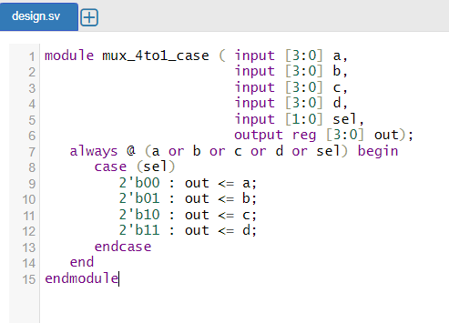

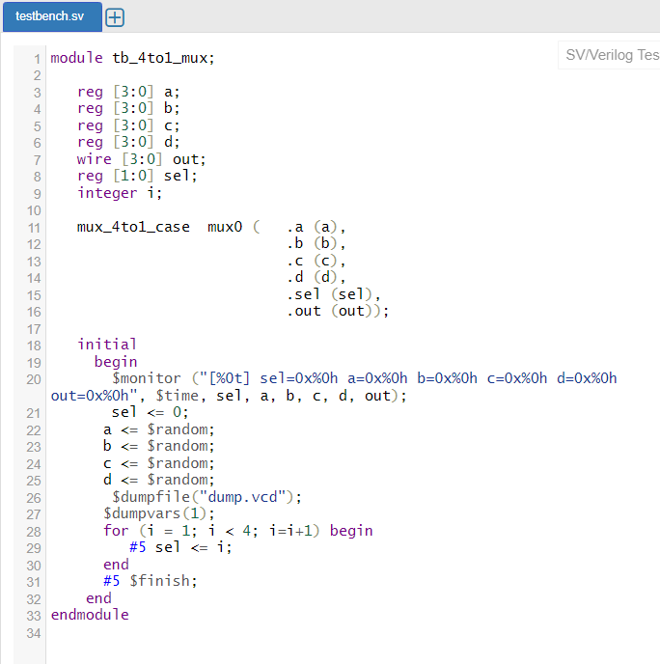

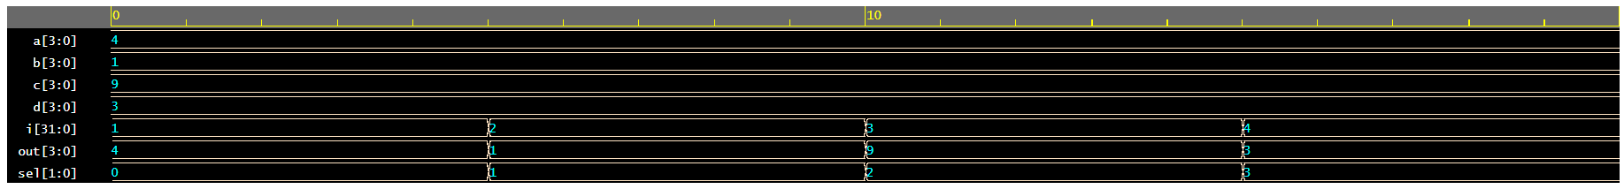

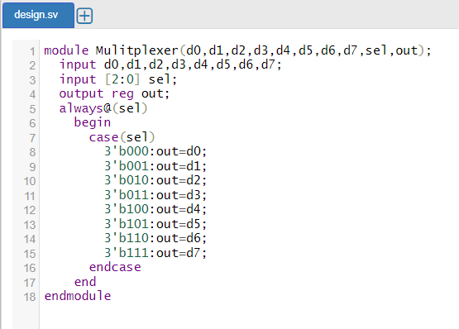**Question 2: Write a Verilog code to design an 8:1 Multiplexer and verify the same.**

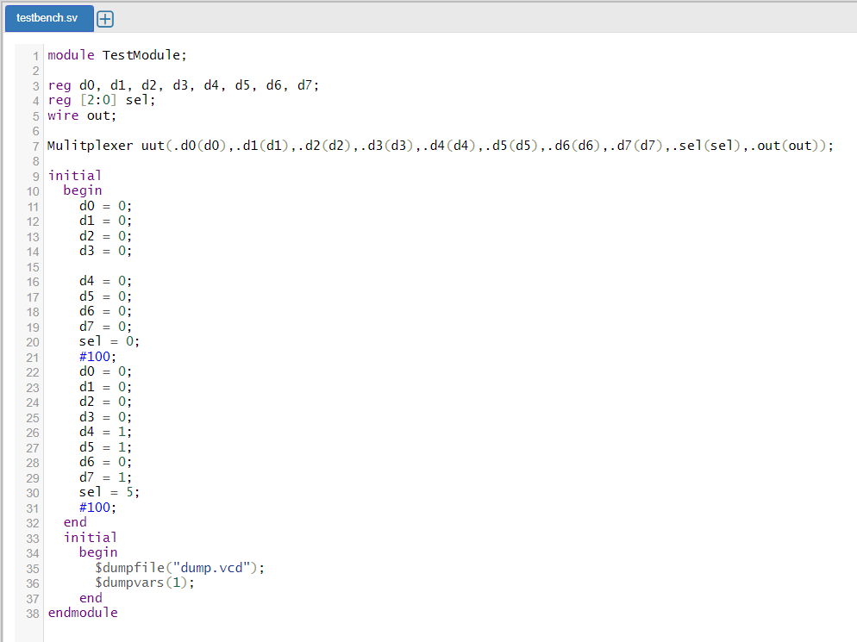

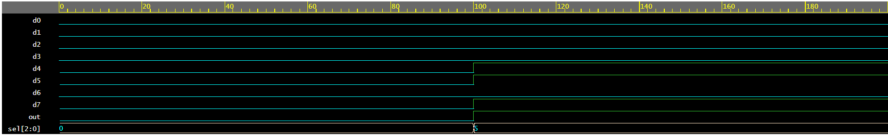

**Question 3: Write a Verilog code to design a 1:4 Demultiplexer and verify the same.**

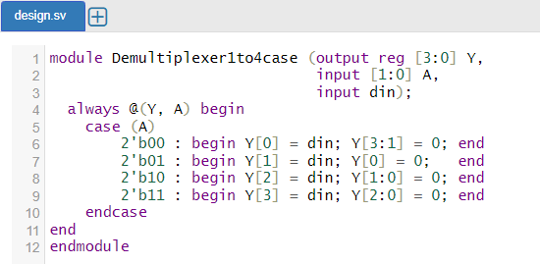

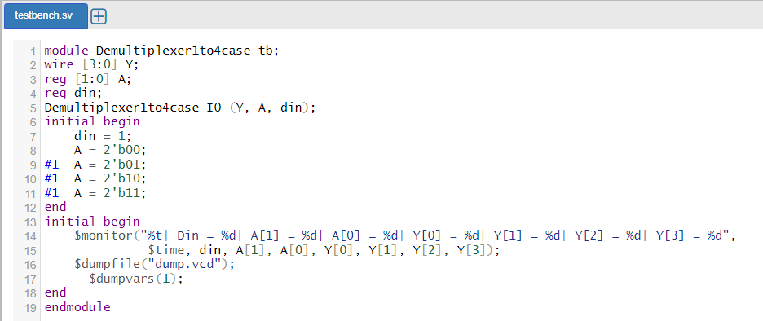



**Question 4: Write a Verilog code to design a 1:8 Demultiplexer and verify the same.**

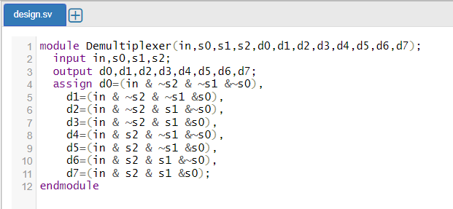

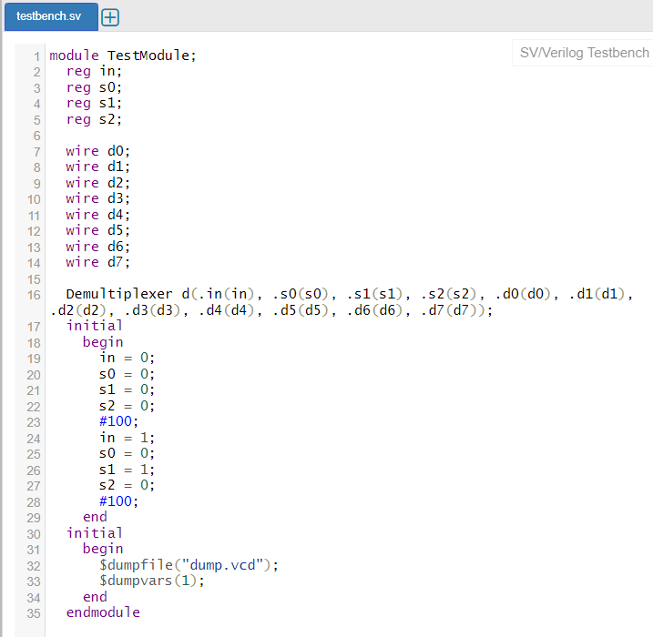

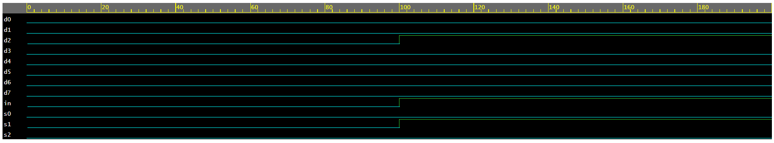

**Question 5: Write a Verilog code to design a 3:8 Decoder and verify the same.**

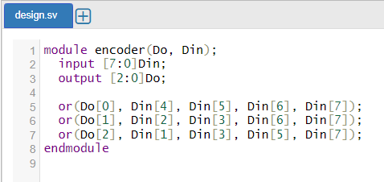

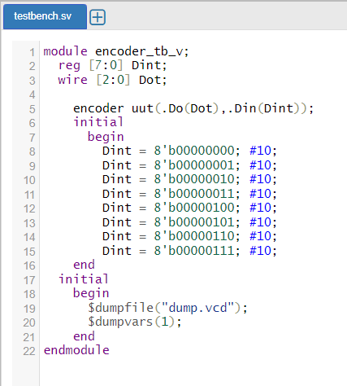



**Question 6: Write a Verilog code to design a 8:3 Encoder and verify the same.**



